Dear Parent,
Does your child love to twirl, play make believe and dress-up?
Then she will LOVE becoming a Princess Ballerina!

Each week she’ll hop, skip and twirl through an imaginary adventure! By encouraging your child’s creativity and independence in a fun and supportive atmosphere you’ll see your child blossom before your eyes!

Princess Ballerinas classes feature:
- Unique theme-based classes that will keep your child excited for dance class week after week! In fact, she’ll never see the same theme twice!
- Caring Instructors who can’t WAIT to share their love for dance with your little one!
- Princess Ballerinas classes also offer fun bonuses like coloring pages, sticker charts and award certificates to celebrate your child’s success along the way!

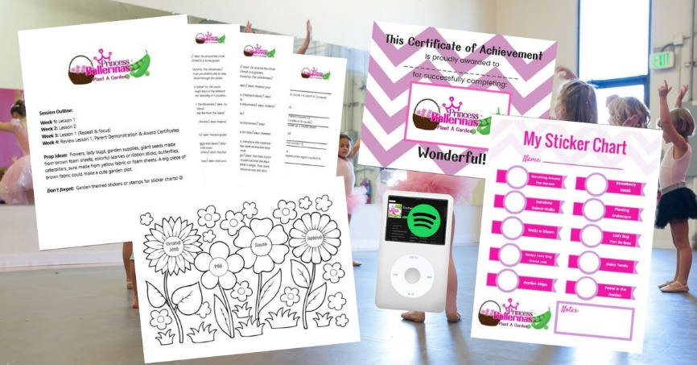

What Happens In A Princess Ballerinas Dance Class?
- Each class begins by warming up our muscles, stretching and reviewing our ballet positions during warm-up.
- We practice our Princess Ballerina dance moves (and review their fancy French names) like relevé, plié, and jeté.
- We travel to magical lands and pretend to be things like beautiful flowers, fairies, birds, bees, and butterflies.
- We practice our Princess Ballerinas dance routine that we can’t WAIT to perform for you!
- Each class ends with your child getting a stamp or sticker to reward and celebrate her progress and success!

Watch your Princess Ballerina blossom!

